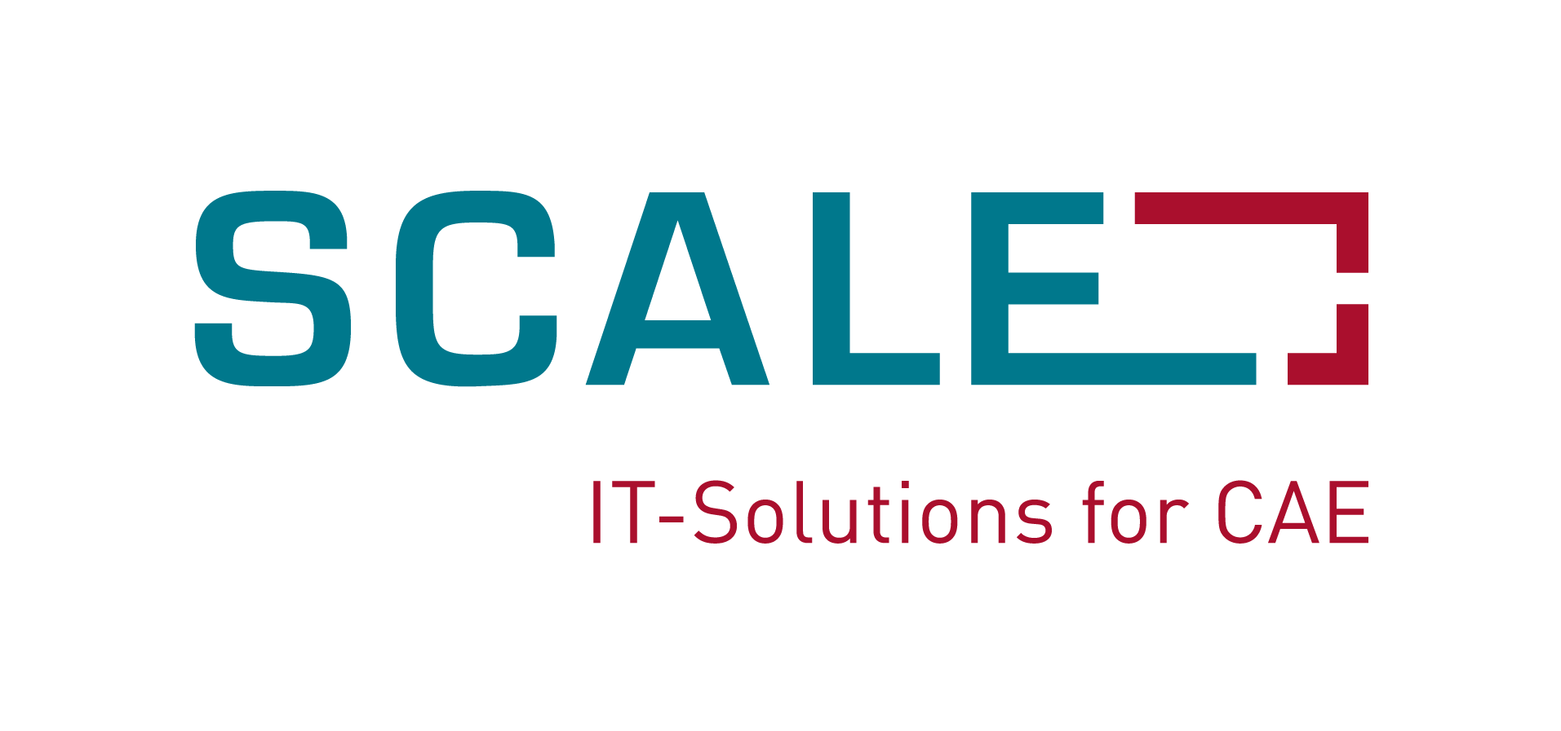
Press Release 5/2014
DYNAmore GmbH
Gesellschaft für FEM
Ingenieurdienstleistungen
DYNAmore forms subsidiary SCALE
for SDM software solutions
Stuttgart, 23 October 2014 –

DYNAmore GmbH has founded a new wholly-owned subsidiary known as SCALE GmbH. The aim behind this move is to offer software solutions and IT services for process and data management and for FE methods development in the automotive industry. In the past years, DYNAmore and SCALE have created a variety of different software products under contract to AUDI:

LoCo: Simulation model management, variant management, model assembly and load case creation, depiction of CAE processes
CAViT: Integrated provision and comparison of simulation and test results.
Status.E: Monitoring of the development status of vehicle projects, including document management.

The LoCo product in particular is being intensively used at many different simulation units, with currently over 400 users at Audi and at a large number of contracted service providers. LoCo is also being phased in at other brand divisions of the Volkswagen group.

The reason for establishing SCALE GmbH is to further develop and market this and other software products both within the Volkswagen group and beyond it as well. The name SCALE stands for "Scalable Solutions in Simulation Data and Process Management", solutions that can also be used as a shared platform with external development partners.

In order to meet our operational, support and development obligations for the LoCo, CAViT and Status.E software products, 20 members of our simulation and process management staff will transfer from DYNAmore in Dresden and Ingolstadt to the newly founded SCALE GmbH. This staff transfer will have no effect on crash analysis activities using LS-DYNA as this work will continue to be performed at DYNAmore.

In a statement, Dr. Heiner Müllerschön, Managing Director of SCALE says that "in the fast growing field of simulation and process management, it was important to us that we be able to more easily develop our software into standardized products. With AUDI, we have a strong partner who shares our vision and who is working with us to further develop our products. At the same time, we are now able to offer our solutions to other customers both within the Volkswagen group and beyond it. We are seeing a large amount of interest in the market and are convinced that the user base will expand greatly over the coming years.“

The DYNAmore name stands for excellent support when it comes to the numerical solution of non-linear physical problems. The product portfolio contains the LS-DYNA finite element software, the pre- and postprocessor called LS-PrePost and the optimization software known as LS-OPT. We also offer numerous FE models for crash simulation (dummies, barriers, pedestrians, human models, etc.). Core activities include support, sales, training, engineering services, software development and system integration. DYNAmore is among the top names when it comes to pilot and development projects for the simulation of non-linear dynamic problems.

More information:
DYNAmore GmbH
Industriestr. 2, D-70565 Stuttgart
Tel.: +49(0)7 11 - 45 96 00 – 0
Fax: +49(0)7 11 - 45 96 00 - 29
E-mail: info@dynamore.de
Internet: www.dynamore.de

